**Table 1**

|  |  |  |  |  |  |
| --- | --- | --- | --- | --- | --- |
| **Test Name** | | Reported Bug 1 of Hotel Reservation System Test 1.1 | | | |
| **Use Case Tested:** | | Check Out | | | |
| **Test Description:** | | This test was performed to test the Check Out Use Case of the Hotel Reservation System. System checkout the customer when the customer wants to leave. Customer can pay the final bill using Check Out. The functionalities of the Use Case were tested step by step and final results were recorded. | | | |
| **Pre-conditions** | | * The main menu of Hotel Reservation System is displayed to the user. | | | |
| **Post-conditions** | | 1. Normal flow and alternative flows where checkout is successful.  * The booking status is updated to CHECKED_OUT. * The room status is updated to READY. * The credit card authorizer was asked to authorize the amount on the invoice. * The booking can no longer be found as an active booking by roomId.  1. All other unsuccessful scenarios  * No change to anything. | | | |
| **Result (Pass/Fail/Warning/Incomplete)** | | **Failed** | | | |
|  | **TEST STEP** | | **EXPECTED TEST RESULTS** | P | F |
|  | User enters Room Number | | System displays final invoice to the user. (**Service Charges are displayed as $0.00**) |  |  |
| Then display prompt to accept the charges. |  |  |
|  | User accepts the charges | | System displays the prompt to select and enter Credit Card Type. |  |  |
|  | User enters selected Credit Card Type | | System displays the prompt to enter Credit Card Number. |  |  |
|  | User enters selected Credit Card Number | | System displays the prompt to enter Credit Card CCV Number. |  |  |
|  | User enters selected Credit Card CCV Number | | System displays checkout debit message to the user. |  |  |
|  | If the user entered Room Number not found | | System displays “No active booking found “error message to the user. |  |  |
|  | If the user entered invalid credit card details or insufficient balance in the credit card. | | System display a charges not accepted message and a checkout cancelled message. |  |  |
|  | If the user entered null inputs for the Room Number or for the credit card type | | System displays cancelled message to the user. |  |  |

**Table 2**

|  |  |  |  |  |  |  |
| --- | --- | --- | --- | --- | --- | --- |
| **Test Data Table** | | | | | | |
| **Data Field Name** | **1** | **2** | **3** | **4** | **5** | **6** |
| Room Number | 101 | 201 | 120 (**This Room Number doesn’t exists)** | 301 | Null | 401 |
| Credit Card Type | MASTERCARD | DEBIT | MASTERCARD | DEBIT | MASTERCARD | Null |
| Credit Card Number | 26458 | 28543 | 37588 | 59673 **(Invalid credit card)** | 37492 | 0 |
| Credit Card CCV Number | 528 | 438 | 398 | 264 | 758 | 0 |

* **Output of the buggy behavior of Reported First Bug:-**

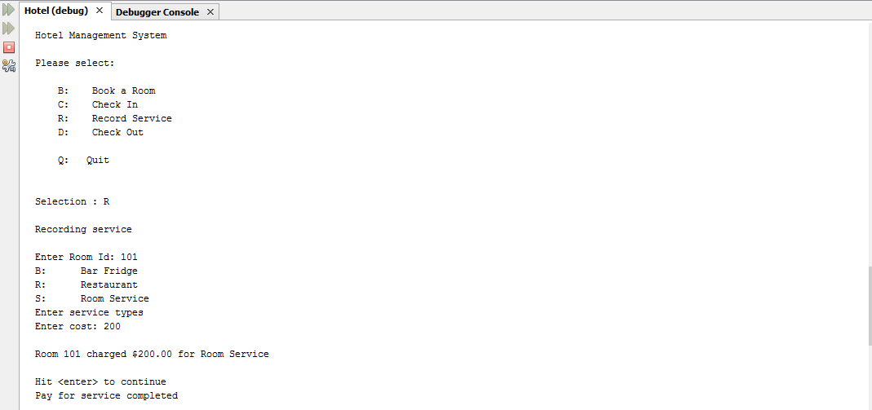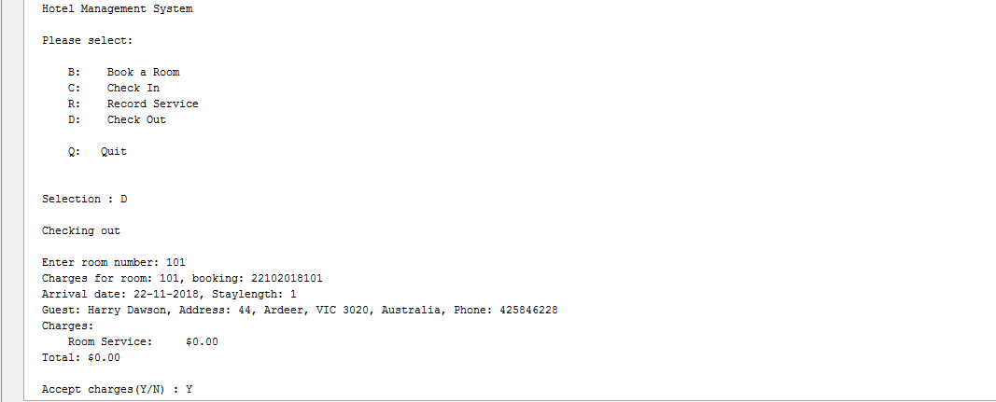

## ***Figure 1***